Long “New Email” Version

NAME
Title/Position
Northern Intermountain
Professional Ski Instructors of America
American Association of Snowboard Instructors
E. email@address.org
P.O. Box 9429, Boise, ID, 93707
P. (Personal Phone if you want to list it) O. 303.987.9390
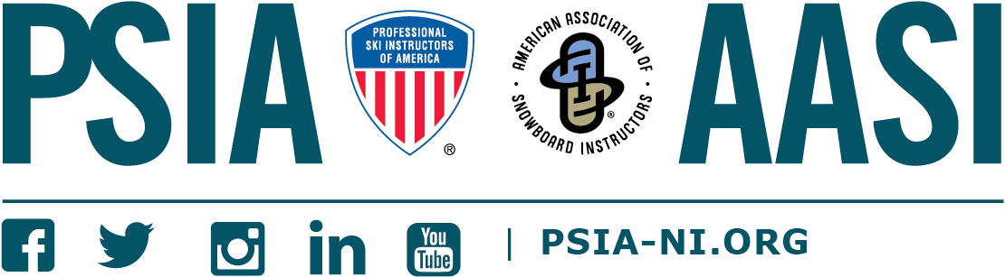

Short “Reply” Version

NAME
Title/Position
Northern Intermountain
Professional Ski Instructors of America
American Association of Snowboard Instructors
E. email@address.org P. (Personal Phone if you want to list it)

