Long “New Email” Version

NAME
Title/Position
Northwest
Professional Ski Instructors of America
American Association of Snowboard Instructors
E. email@address.org
P.O. Box 615, Wenatchee, WA, 98807
P. (Personal Phone if you want to list it) O. 206.244.8581
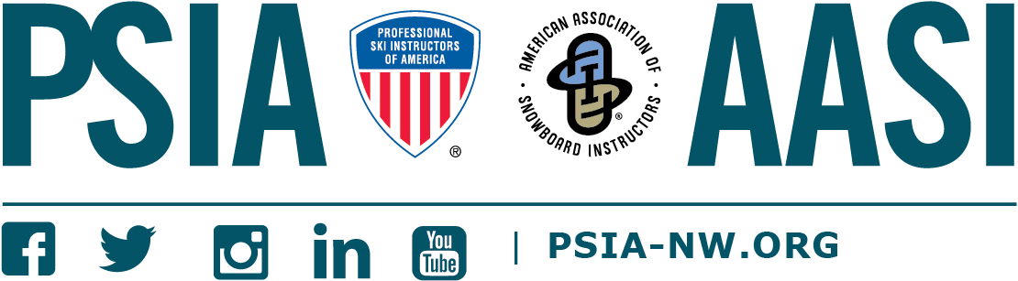

Short “Reply” Version

NAME
Title/Position
Northwest
Professional Ski Instructors of America
American Association of Snowboard Instructors
E. email@address.org P. (Personal Phone if you want to list it)

